**Defect Report**

* **Defect Id: 8**
* **Status: Closed**
* **Reported by: Bishoy**
* **Assigned to: Malek**
* **Date:**  **13/5/2023**

**Defect description: after entering the student id = "123456ss", an** *INVALID_STUDENT_ID_GENERAL* **exception must be thrown but nothing was thrown, and the student id was stored normally.**

**The id mays end with at most one alphabet.**

* **Steps:**

1. **Open the application**
2. **Enter the student id = “123456ss”**
3. **Run the program**

* **Severity: Low**
* **Priority: High**
* **Date Closed: 14/5/2023**
* **Fixed By: malek**
* **Screenshot for the Defect:**

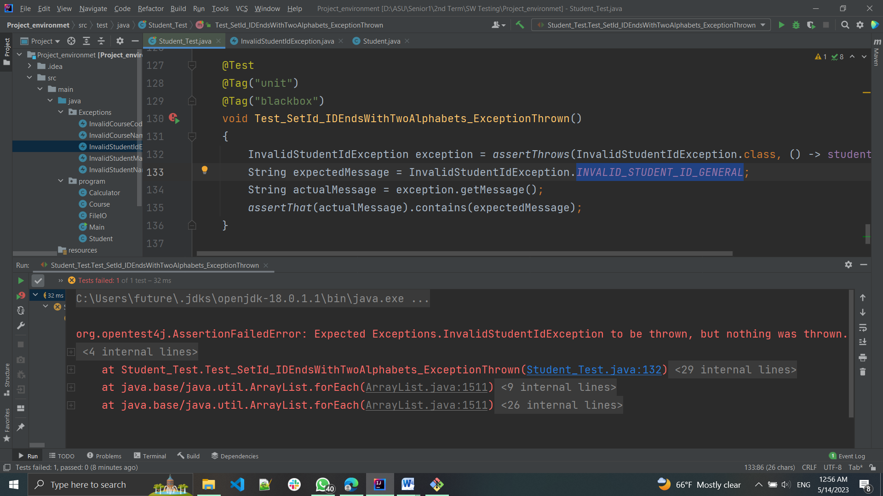

* **Screenshot after fixing:**

